running analysis intake form

Patient’s Name ________________________________________ Date of Birth _________
(last) (first) (middle)

Mailing Address ____________________________________________________________
(number and street) (city) (state) (zip)
Home # (___) ________ Cellular # (___) ________ Work # (___) _________
Social Security # _____________________Employer _____________________________
Email address ___________________________________Add to eNewsletter List? Y N
In Case of Emergency Contact ________________________ Phone # (___) ____________
Referring Physician ____________________________ Date of Injury _________________
Primary Care Physician _______________________________________________________
Would you like us to provide appointment reminders? Y/N Can we leave a message regarding appointment times on your home phone? Y/N work phone Y/N cell phone Y/N
► IF PATIENT IS UNDER THE AGE OF 18 ◄

Mother’s Name _________________________________________ Employer __________________________
Work # (___) ______________________________ Social Security # _______________________________
Father’s Name __________________________________________ Employer _________________________
Work # (___) ______________________________ Social Security # _______________________________
For patients under 18 years of age, the parent, relative, or person escorting the patient is responsible for any payments due at the time of the service.
- I understand that I am responsible for all charges incurred regardless of insurance or third party liability.
- I authorize contact by the use of my mobile/cell phone number for discussing treatment, confirming appointments and resolution of the balance of my account.
- I authorize Sapphire Physical Therapy to release any medical information necessary to process my claim to my insurance company or to any other concerned third party.
- I understand that I will bear the cost for all associated collections and/or attorney/legal fees if my account is placed with a 3rd party agency and/or attorney for collections or legal action.
- I authorize my insurance company or any other concerned third party to make payment directly to Sapphire Physical Therapy.

_______________________________________ _______________
Signature Date

Sapphire Physical Therapy Financial Policy

This is an agreement between Sapphire Physical Therapy and _________________________________________________.
(please print name)

In this agreement the words “you,” “your,” and “yours” mean the Patient. The word “account” means the account that has been established in your name to which charges are made and payments credited. The words “we,” “us,” and “our” refer to Sapphire Physical Therapy.

By executing this agreement, you are agreeing to pay for all services that are received.

Please select the option(s) you prefer:
_____I will make payments at time of service
_____I will make a payment arrangement for my account
_____Work Related My workers compensation carrier authorized physical therapy
_____Motor Vehicle A motor vehicle insurance company authorized physical therapy
_____Voc Rehab Montana Voc Rehab authorized my physical therapy

Monthly Statement: If you have a balance on your account, we will send you a monthly statement. It will show separately the previous balance, any new charges to the account, the finance/rebilling charge, if any, and any payments or credits applied to your account during the month.

Payment options if you have NO insurance:
- You choose to pay by _____cash, ____check, or _____credit card at the time the services are rendered. Our cash payment option for patients without insurance is $125 per visit. Payment is expected at time of service. If extenuating circumstances should arise, you can discuss a payment plan with our Practice Manager, Jen Dreiling.
Payment options if you have insurance:
- If you still have a deductible to meet, you choose to pay $125 by ____cash, ____check, or ____credit card at the time services are rendered. We will send your claim to your insurance carrier and will bill you for any additional patient responsibility, if any, which is determined by your carrier.
- You choose to pay your co-payment, determined by your insurance carrier, by ____cash, ____check, or ____credit card at the time services are rendered. If there is a balance on your account at the end of the month we will bill you accordingly. Any balances without a payment within 30 days of the date of service will be charged a recurring $6 monthly rebilling/finance charge until services are paid in full.

- You choose to pay your Running Analysis evaluation by ____cash, ____check, or ____credit card at the time services are rendered. If there is a balance on your account at the end of the month we will bill you accordingly. Any balances without a payment within 30 days of the date of service will be charged a recurring $6 monthly rebilling/finance charge until the services are paid in full.
Payments: Unless other arrangements are approved by either John Fiore, Owner, or Jennifer Dreiling, Practice Manager, the balance of your statement is due and payable when the statement is issued, and is past due if not paid by the end of the month.
Charges to Account: We shall have the right to cancel your privilege to make charges against your account at any time. Future visits would then need to be paid in full at the time of service.

Contracted Insurance: If we are contracted with your insurance company, we must follow our contract and their requirements. It is the insurance company that makes the final determination of your coverage eligibility. If your insurance company requires a referral and/or preauthorization, you are responsible for obtaining it. Failure to obtain the referral and/or preauthorization may result in a lower payment from the insurance company, and/or a higher patient financial responsibility.

Non-contracted Insurance: Insurance is a contract between you and your insurance company. We are NOT a party to this contract, in most cases. We will bill your primary insurance as a courtesy to you. Although we may estimate what your insurance company may pay, it is the insurance company that makes the final determination of your coverage eligibility. You agree to pay any portion of the charges not covered by insurance.

Finance Charge: A finance charge will be imposed on your account when it has not been paid within (30) days of the statement date. The finance charge will be $1 per billing period and will accrue every (30) days when a payment has not been made on your account.

Re-billing Fee: A re-billing fee of $5 will be imposed on each account that is over (30) days past due and a payment has not been made, unless other payment arrangements and a payment plan have been agreed upon.

Past Due Accounts: If your account becomes past due, we will take necessary steps to collect this debt. We reserve the right to refer your account to an attorney or collection agency. You agree to pay all attorney fees and collection costs incurred in enforcing the terms of this agreement.

Returned Checks: There is a $25 fee for any checks returned by your bank.

Missed Appointments: We reserve the right to charge a $20 fee for a third consecutive missed appointment. The fee must be paid before a new appointment is scheduled. We also may ask you to switch to same day only scheduling.

Workers Compensation: We require written approval/authorization by your worker’s compensation carrier prior to your initial visit. If your claim is denied, you will be responsible for your payment in full.

Motor Vehicle Accidents: If the insurance policy involved in any motor vehicle accident claim does not accept liability for your claim, you will be held responsible for your payments in full.

Effective Date: Once you have signed this agreement, you agree to all of the terms and conditions contained herein and the agreement will be in full force and effect.

Patient’s name: _________________________________________________________

Responsible Party: _______________________________________________________
(if not the patient)

Signature: ______________________________________________________________

Date: __________________________________________________________________

Release of Information

Sapphire Physical Therapy
1705 Bow St.
Missoula, MT 59801
(406) 549-5283
(406) 549-5392 fax

Thank you for referring your patient to Sapphire Physical Therapy.

Please forward the medical records regarding this patient so we may provide proper treatment to your patient.

I authorize the release of and correspondence regardingmy (or my dependent’s) medical records to Sapphire Physical Therapy.

Date __________________________________________

Patient Name ___________________________________

Date of Birth ___________________________________

_______________________________________ _______________
Signature Date

NOTICE OF PRIVACY PRACTICES

This Notice of Privacy Practices contains a detailed description of how our office will protect your health information, your rights as a patient, and our common practices in dealing with patient health information.

Uses and Disclosure of Health Information:
We will use and disclose your health information in order to treat you or to assist other health care providers in treating you. We will also use and disclose your health information in order to obtain payment for our services or to allow insurance companies to process insurance claims for services rendered to you by us or other health care providers. Finally, we may disclose your health information for certain limited operational activities such as quality assessment, licensing, accreditation and training of students.

Uses and Disclosures Based on Your Authorization:
Except as stated in more detail in the Notice of Privacy Practice, we will not use or disclose your health information without your written authorization.

Uses and Disclosures Not Requiring your Authorization:
In the following circumstances, we may disclose your health information without your written authorization:
- To family members or close friends who are involved in your health care
- For certain limited research purposes
- For purpose of health and safety
- To Government agencies for purposes of their audits, investigations, and oversight activities
- To Government authorities to prevent child abuse and domestic violence
- To law enforcement authorities to protect public safety or to assist in apprehending criminal offenders
- When required by court orders, search warrants, subpoenas, and as otherwise required by law

Patient Rights:
As our patient, you have the following rights:
- To have access to and/or copies of your health information
- To receive an account or certain disclosures we have made of your health information
- To request restrictions as to how your health information is used or disclosed
- To request that we communicate with you in confidence.
- To request that we amend your health information
- To receive notice of our privacy practices

Please contact us with any questions, concerns, or complaints regarding our privacy practices.

I acknowledge that I was provided a copy of the Notice of Privacy Practices and that I have read (or had the opportunity to read if I so choose) and understand the Notice.

______________________________________________________
Patient Name (please print)

______________________________________________________
Parent or Authorized Representative (if applicable)

_______________________________________ _______________
Signature Date

Running history form

*Note: This is a confidential record and will be kept in your PT chart. Information contained here will not be released to anyone without your authorization to do so.

Last Name _____________________ First Name _______________________ Middle _________

Today’s Date ____ /____ /____ Date of Birth ____ /____ /____

Date of last Physician exam ____ /____ /____

BMI: Height _________ Weight __________

History of Present Problem

Please answer the following questions

Please explain the reason for your desire for running analysis
______________________________________________________________________________________________________________________________________________________________

- Do you have pain with running? Yes / No (you may skip questions )
- When did you first notice the problem?
_________________________________________ _
- __________________________________________

- On a scale of 0-10 (0 is no pain, 10 is worst pain imaginable), circle the
number that best describes your worst pain associated with running?
0 1 2 3 4 5 6 7 8 9 10

Please mark the location of the pain

on the diagram below.

- At what point is your pain the worst?
At the beginning of a run
Pain increases the more I run
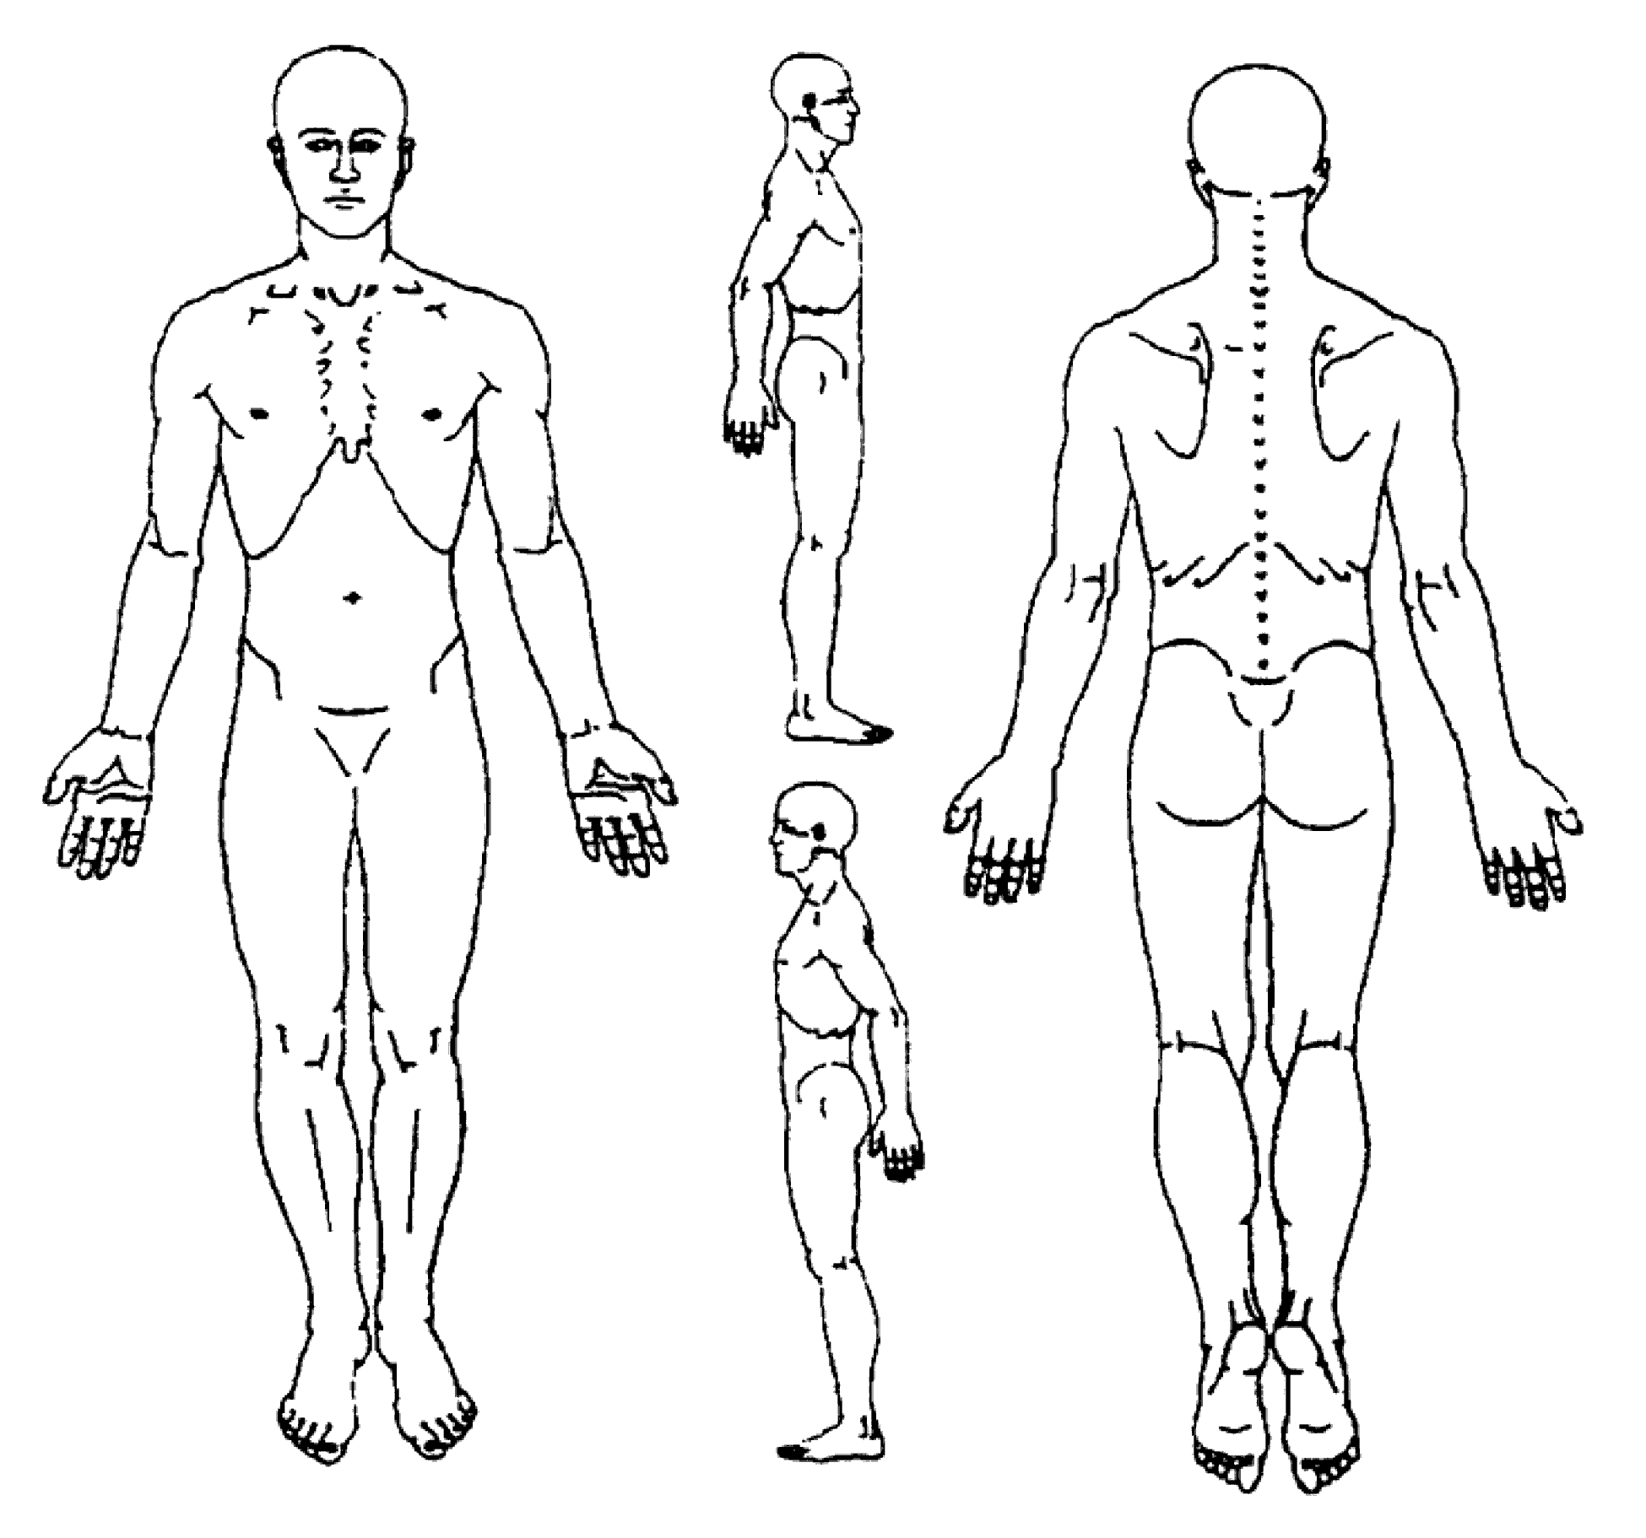
I have no pain until mile___ of a run
Pain is worst within hours after the run

- How long does the pain last after running?

- How many years have you been running?

- Have you ever had a running related injury before?
If so, please explain:__________________________
___________________________________________

- How would you classify your level of running?
  - Recreational
  - Competitive

- What is your typical race distance?
  - 5k
  - 10k
  - ½ marathon
  - Marathon
  - Ultramarathon

- Typical running surface?
  - Road- flat
  - Road- hilly
  - Trail- flat
  - Trail- hills
  - Treadmill
  - Other _________

- Current Running Mileage (ideal)
  - Weekly
  - Long Run Distance

- Average Pace - minutes/mile (range

- Do you do speed work? Yes / No

- Do you do hill work? Yes / No

- Do you regular strength training? Yes / No

- Are you comfortable on a treadmill? Yes / No?

- Please list other sports / fitness activities: _______________________________________

- Running shoe brand / model:

- Shoe age:

- Do you wear orthotics? (If yes, are they custom or generic?)

- What is your occupation?

  - How would you describe level of activity / positions required by your job?
    - Mostly sitting
    - Standing / light activity on feet
    - Moderate to heavy activity

- Have you ever had a stress fracture? Yes / No

- Do you worry about your weight or body composition? Yes / No

- Do you limit or carefully control foods that you eat? Yes / No

- If appropriate, is menstruation regular or irregular? Yes / No

Doctor recommendation _____  Friend recommendation _____  Saw sign _____  Internet search _____  Website _____ | Location _____  Prior patient _____  Newspaper Ad _____  Phone Book _____  Other _____  Please explain:
How did you hear about Sapphire Physical Therapy? Please check all that apply.

